Warning – Electronic Limited Slip Differential (ELSD) – CGEA1.3

Functional Description

The purpose of the ELSD Warnings is to provide instruction to the driver for engaging the Electronic Limited Slip Differential (ELSD) and as well as provide status when ELSD is engaged or disengaged. This STSS is primarily targeted for U55x. Alternate STSS to be used for other programs is Elocker warning STSS -> “Warning – ELD - CGEA 1.3 – vx.x”

The ELSD Warning function correlates the RearDiffLckMsg2_D_Rq signal, RearDiffSrvcRqd_B_Rq signal, the ELSD_Cfg and the operational mode to display the appropiate warning in the message center. Also for specific case of ELSD turned off, a soft chime is played

An RTT is also associated with the ELSD warning messages based on RearDiffLckLamp_D_Rq2 signal status. For programs that cannot display an RTT, for example L0 Clusters, it is suggested to use a telltale for iconic indication. Refer ELSD Telltale CGEA1.3 STSS for details.

Interfaces

Interface Context Diagram (I/O Block Diagram)
Figure 1 Warning – ELSD Context Diagram

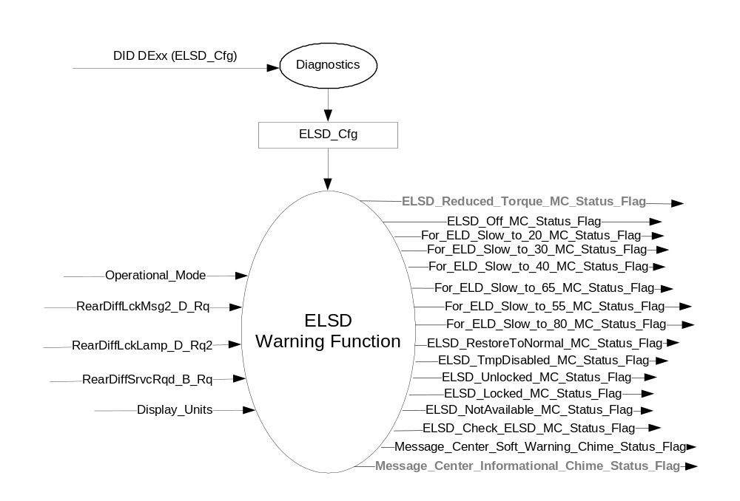

Inputs
      - INTERNAL:
- Operational_Mode
- Display_Units – to differentiate between English and Metric Mode

- MUX message from the HS_CAN bus
  - RearDiffLckMsg2_D_Rq – CAN Signal which informs the state of ELSD

- RearDiffLckMsg2__D_Rq Signal
Signal Name | Size  (bits) | Detail | Units | Res | State Encoded | Min. | Max.
RearDiffLckMsg2_D_Rq | 4 |  | SED | 1 |  | 0 (0x0) | 15  (0xF)
 |  | NormalNoMessage |  |  | 0x0
 |  | LockerSpeed1 |  |  | 0x1
 |  | LockerSpeed2 |  |  | 0x2
 |  | LockerSpeed3 |  |  | 0x3
 |  | LockerSpeed4 |  |  | 0x4
 |  | LockerSpeed5 |  |  | 0x5
 |  | LockerEnabled |  |  | 0x6
 |  | LockerDisabled |  |  | 0x7
 |  | ElsdOverheated |  |  | 0x8
 |  | ElsdRestored |  |  | 0x9
 |  | ElsdOff |  |  | 0xA
 |  | LockingFeatureNotAvailable |  |  | 0xB
 |  | ElsdReduced |  |  | 0xC
 |  | NotUsed_1 |  |  | 0xD
 |  | NotUsed_2 |  |  | 0xE
 |  | NotUsed_3 |  |  | 0xF

  - RearDiffLckLamp_D_Rq2 – CAN Signal which informs the state of RTT Indication

- RearDiffLckLamp_D_Rq2 Signal
Signal Name | Size  (bits) | Detail | Units | Res | State Encoded | Min. | Max.
RearDiffLckLamp_D_Rq2 | 4 |  | SED | 1 |  | 0 (0x0) | 3  (0x3)
 |  | Off |  |  | 0x0
 |  | On |  |  | 0x1
 |  | Flash |  |  | 0x2
 |  | Triggered |  |  | 0x3

- RearDiffSrvcRqd_B_Rq Signal

Signal Name | Size  (bits) | Detail | Units | Res | Offset | State Encoded | Min. | Max.
RearDiffSrvcRqd_B_Rq | 1 |  |  |  |  |  | 0 (0x0) | 1 (0x1)
 |  | Off |  |  |  | 0x0
 |  | On |  |  |  | 0x1

Outputs
- ELSD_Off_MC_Status_Flag is used to control the Warning displayed in the message center that informs about “ELSD Off See Owners Manual”. Has a soft chime associated with it
- ELSD_RestoreToNormal_MC_Status_Flag is used to control the Warning displayed in the message center. It informs user about ELSD restored to Normal status
- ELSD_TmpDisabled_MC_Status_Flag is used to control the Warning displayed in the message center. It informs user about ELSD temporarily disabled due to overheat or other unexpected conditions
- ELSD_Unlocked_MC_Status_Flag is used to control the Warning displayed in the message center. It informs user that ELSD is unlocked
- ELSD_Locked_MC_Status_Flag is used to control the Warning displayed in the message center. It informs user that the ELSD is locked
- ELSD_NotAvailable_MC_Status_Flag is used to control the Warning displayed in the message center. It informs user that the ELSD Locking Feature is not available in the Selected Mode
- ELSD_Check_ELSD_MC_Status_Flag is used to control the Warning displayed in the message center. It informs user that a service is required for the ELSD
- Message_Center_Soft_Warning_Chime_Status_Flag is a soft chime to be played (set to Active) when ELSD is Off
- For_ELD_Slow_to_20_MC_Status_Flag that is used to control the Warning displayed in the message center.
- For_ELD_Slow_to_30_MC_Status_Flag that is used to control the Warning displayed in the message center.
- For_ELD_Slow_to_40_MC_Status_Flag that is used to control the Warning displayed in the message center.
- For_ELD_Slow_to_65_MC_Status_Flag that is used to control the Warning displayed in the message center.
- For_ELD_Slow_to_55_MC_Status_Flag that is used to control the Warning displayed in the message center.
- For_ELD_Slow_to_80_MC_Status_Flag that is used to control the Warning displayed in the message center
- ELSD_Reduced_Torque_MC_Status_Flag is used to control the Warning displayed in the message center. It informs user that the eLSD torque is reduced and that the system is not at its full torque possible. Reduction can be from a spare tire, missing CAN signal, thermal warning, or other eLSD faults
- Message_Center_Informational_Chime_Status_Flag is a soft chime to be played (set to Active) when ELSD _Reduced_Torque_MC_Status_Flag is active

Function/Performance

Operational Modes

Mode | Differentiating Vehicle Conditions
Sleep Mode | OFF
Limited Mode | OFF
Normal Mode | ELSD Warnings OFF/ON
Crank Mode | ELSD Warnings OFF/ON

Voltage Levels

Refer to the Cluster Features Table located in the Operational Modes and Voltage Range Strategies Section of this SPSS

Human-Machine Interface

Visual

Indicator Graphics / Display Format
Message Center Text Warning Message as defined in section 1.3.5.7 of this document.

1.3.3.1.2 Indicator Color Coordinates

Reference section COLOR & ILLUMINATION REQUIREMENTS (GRAPHICS).

Audio

- When ELSD_Off_MC_Status_Flag is Active, then Soft Warning Chime is played when played i.e., Message_Center_Soft_Warning_Chime_Status_Flag is set to Active.
- When ELSD _Reduced_Torque_MC_Status_Flag is set to active, then the Message_Center_Informational_Chime is played.
- No chime for other cases.

Switch Control Logic

None.

System Accuracy

Within 100 msec of receiving a message that results in a change of state the cluster will update the output flag to the proper state.

Operation: Performance and Functional

Subsystem Algorithm Flowchart / State Diagram

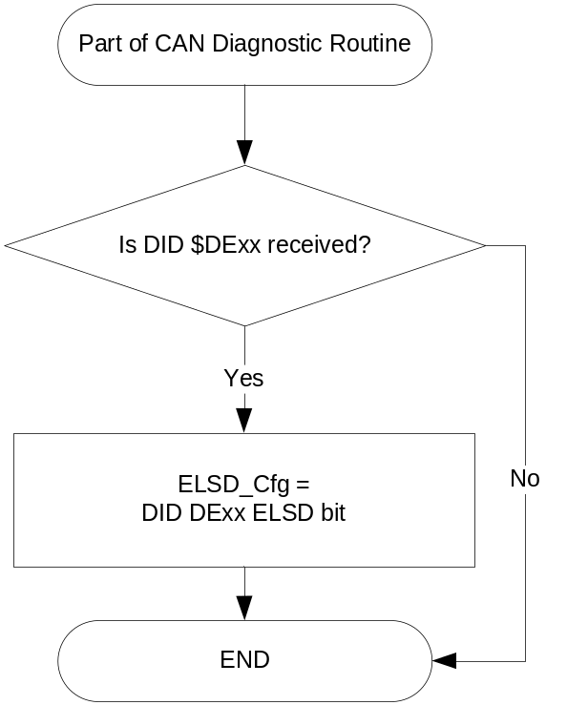
- State Matrix for ELSD Warnings

Operational _Mode | ELSD_ Cfg | RearDiffLckMsg2 _D_Rq | RearDiffSrvcRqd_B_Rq | ELSD_Off_MC_Status_Flag | ELSD_RestoreToNormal_MC_Status_Flag | ELSD_TmpDisabled_MC_Status_Flag | ELSD_Unlocked_MC_Status_Flag | ELSD_Locked_MC_Status_Flag | ELSD_NotAvailable_MC_Status_Flag | ELSD_Check_ELSD_MC_Status_Flag | ELSD_Reduced_Torque_MC_Status_Flag | Message_Center_Soft_Warning_Chime_Status_Flag | Message_Center_Informational_Chime_Status_Flag
Normal  Or Crank | Enabled  (0x1) | LockingFeatureNotAvailable (0xB) | Off (0x0) | Inactive | Inactive | Inactive | Inactive | Inactive | Active | Inactive | Inactive | Inactive | Inactive
Normal  Or Crank | Enabled  (0x1) | LockerEnabled (0x6) | Off (0x0) | Inactive | Inactive | Inactive | Inactive | Active | Inactive | Inactive | Inactive | Inactive | Inactive
Normal  Or Crank | Enabled  (0x1) | LockerDisabled (0x7) | Off (0x0) | Inactive | Inactive | Inactive | Active | Inactive | Inactive | Inactive | Inactive | Inactive | Inactive
Normal  Or Crank | Enabled  (0x1) | eLSDOverheated(0x8) | Off (0x0) | Inactive | Inactive | Active | Inactive | Inactive | Inactive | Inactive | Inactive | Inactive | Inactive
Normal  Or Crank | Enabled  (0x1) | eLSDRestored(0x9) | Off (0x0) | Inactive | Active | Inactive | Inactive | Inactive | Inactive | Inactive | Inactive | Inactive | Inactive
Normal  Or Crank | Enabled  (0x1) | eLSDOff (0xA) | Off (0x0) | Active | Inactive | Inactive | Inactive | Inactive | Inactive | Inactive | Inactive | Active | Inactive
Normal  Or Crank | Enabled  (0x1) | ElsdReduced (0xC) | Off (0x0) | Inactive | Inactive | Inactive | Inactive | Inactive | Inactive | Inactive | Active | Inactive | Active
Normal  Or Crank | Enabled  (0x1) | X | On (0x1) | Inactive | Inactive | Inactive | Inactive | Inactive | Inactive | Active | Inactive | Inactive | Inactive
Normal | Enabled  (0x1) | Missing or never received | Off (0x0) | Inactive | Inactive | Inactive | Inactive | Inactive | Inactive | Inactive | Inactive | Inactive | Inactive
All Other Cases |  |  |  | Inactive

- State Matrix for ELSD Warnings - Continued

Operational _Mode | ELSD_ Cfg | RearDiffLckMsg2 _D_Rq | Display_ Units | For_ELD_ Slow_to_ 20_ MC_Status_ Flag | For_ELD_ Slow_to_ 30_ MC_Status_ Flag | For_ELD_ Slow_to_ 40_ MC_Status_ Flag | For_ELD_ Slow_to_ 65_ MC_Status_ Flag | For_ELD_ Slow_to_ 55_ MC_Status_ Flag | For_ELD_ Slow_to_ 80_ MC_Status_ Flag
Normal  Or Crank | Enabled (0x1) | LockerSpeed1 (0x1) | E | Active | Inactive | Inactive | Inactive | Inactive | Inactive
Normal  Or Crank | Enabled (0x1) | LockerSpeed1 (0x1) | M | Inactive | Active | Inactive | Inactive | Inactive | Inactive
Normal  Or Crank | Enabled (0x1) | LockerSpeed2 (0x2) | E | Inactive | Inacitve | Active | Inactive | Inactive | Inactive
Normal  Or Crank | Enabled (0x1) | LockerSpeed2 (0x2) | M | Inactive | Inactive | Inactive | Active | Inactive | Inactive
Normal  Or Crank | Enabled (0x1) | LockerSpeed3 (0x3) | E | Active | Inactive | Inactive | Inactive | Inactive | Inactive
Normal  Or Crank | Enabled (0x1) | LockerSpeed3 (0x3) | M | Inactive | Active | Inactive | Inactive | Inactive | Inactive
Normal  Or Crank | Enabled (0x1) | LockerSpeed4(0x4) | E | Inactive | Inactive | Inactive | Inactive | Active | Inactive
Normal  Or Crank | Enabled (0x1) | LockerSpeed4(0x4) | M | Inactive | Inactive | Inactive | Inactive | Inactive | Active
Normal | Enabled (0x1) | 0x0, Missing or never received | X | Inactive | Inactive | Inactive | Inactive | Inactive | Inactive
All Other Cases |  |  |  | Inactive | Inactive | Inactive | Inactive | Inactive | Inactive
X=Don’t Care, E = English, M = Metric
- ELSD Warning MC Status Flags to MC Warning Message ID

Description of Warning | MC_Status_Flag | Message center Warning ID
"Electronic Limited Slip Differential Off - See Owners Manual" | ELSD_Off_MC_Status_Flag | W3007
ELSD is currently restored to Normal state from a previous fault or unstable state | ELSD_RestoreToNormal_MC_Status_Flag | W3008
ELSD is currently disabled due to Overheating conditions | ELSD_TmpDisabled_MC_Status_Flag | W3009
Electronic Limited Slip Differenctial is unlocked | ELSD_Unlocked_MC_Status_Flag | W3005
Electronic Limited Slip Differenctial is locked | ELSD_Locked_MC_Status_Flag | W3004
Electronic Limited Slip Differenctial is currently not available in the selected mode | ELSD_NotAvailable_MC_Status_Flag | W3010
Check Electronic Limited Slip differential based on the SrvcRqd CAN Signal | ELSD_Check_ELSD_MC_Status_Flag | W3006
Driver attempts to engage locker at high speed level 1 and mode = english | For_ELD_ Slow_to_20_ MC_Status_Flag | W1003
Driver attempts to engage locker at high speed level 1 and mode = metric | For_ELD_ Slow_to_30_ MC_Status_Flag | W1004
Driver attempts to engage locker at high speed level 2 and mode = english | For_ELD_ Slow_to_40_ MC_Status_Flag | W3525
Driver attempts to engage locker at high speed level 2 and mode = metric | For_ELD_ Slow_to_65_ MC_Status_Flag | W3526
Driver attempts to engage locker at high speed level 3 and mode = english | For_ELD_ Slow_to_55_ MC_Status_Flag | W1005
Driver attempts to engage locker at high speed level 3 and mode = metric | For_ELD_ Slow_to_80_ MC_Status_Flag | W1006
Electronic Limited Slip Differential Reduced Torque | ELSD_Reduced_Torque_MC_Status_Flag | W3011

Operation Description (supports algorithm flowchart /state diagram)

- For definition of how the Message Center arbitrates and displays Active warnings, see the Warning / Alert Display Logic Diagram, located in the Message Center – X Display with W Button Interface section of this SPSS (where X and W are appropriate values in this document)
- For W3011 warning on reduced torque related information, for 4.2” display, the preferred text is “Electronic Limited Slip Differential Reduced Torque”. For 2.3” display, if the spacing constraints allow to display the word “Torque”, please refer to the Program HMI for appropriate text to be displayed

Function Safety Classification (EMC)

Class B

Memory Storage

Parameter Name | Description | Value at  Battery Connect | Value at  Module Wake-up
ELSD_Off_MC_Status_Flag | used to control the Warning displayed in the message center that informs about “ELSD Off See Owners Manual”. Has a soft chime associated with it | INACTIVE (0x0) | INACTIVE (0x0)
ELSD_RestoreToNormal_MC_Status_Flag | used to control the Warning displayed in the message center. It informs user about ELSD restored to Normal status | INACTIVE (0x0) | INACTIVE (0x0)
ELSD_TmpDisabled_MC_Status_Flag | used to control the Warning displayed in the message center. It informs user about ELSD temporarily disabled due to overheat or other unexpected conditions | INACTIVE (0x0) | INACTIVE (0x0)
ELSD_Unlocked_MC_Status_Flag | used to control the Warning displayed in the message center. It informs user that ELSD is unlocked | INACTIVE (0x0) | INACTIVE (0x0)
ELSD_Locked_MC_Status_Flag | used to control the Warning displayed in the message center. It informs user that the ELSD is locked | INACTIVE (0x0) | INACTIVE (0x0)
ELSD_NotAvailable_MC_Status_Flag | used to control the Warning displayed in the message center. It informs user that the ELSD Feature is not available in the Selected Mode | INACTIVE (0x0) | INACTIVE (0x0)
ELSD_Check_ELSD_MC_Status_Flag | used to control the Warning displayed in the message center. It informs user that a service is required for ELSD | INACTIVE (0x0) | INACTIVE (0x0)
Message_Center_Soft_Warning_Chime_Status_Flag | General soft chime to be played (set to Active) when ELSD is Off | INACTIVE (0X0) | INACTIVE (0X0)
ELSD_Cfg | Used to enable/disable eLSD Feature functionaity | Use Stored Value | Use Stored Value
RearDiffLckMsg2 _D_Rq (HS-CAN signal) | Input CAN signal sent from ECM or PCM. | Normal (0x0) | Normal (0x0)
RearDiffLckLamp_D_Rq2 (HS-CAN signal) | Input CAN signal sent from ECM or PCM. | Off (0x0) | Off (0x0)
RearDiffSrvcRqd_B_Rq | Input CAN Signal sent from DCMR to inform if a service check is required for ELSD | Off (0x0) | Off (0x0)
Operational_Mode | 4 state indicator for cluster operational mode | Limited | Limited or Normal or Crank
For_ELD_ Slow_to_20_ MC_Status_Flag | Used to control the state of the warning to the Message Center arbitrator | INACTIVE (0x0) | INACTIVE (0x0)
For_ELD_ Slow_to_30_ MC_Status_Flag | Used to control the state of the warning to the Message Center arbitrator | INACTIVE (0x0) | INACTIVE (0x0)
For_ELD_ Slow_to_40_ MC_Status_Flag | Used to control the state of the warning to the Message Center arbitrator | INACTIVE (0x0) | INACTIVE (0x0)
For_ELD_ Slow_to_65_ MC_Status_Flag | Used to control the state of the warning to the Message Center arbitrator | INACTIVE (0x0) | INACTIVE (0x0)
For_ELD_ Slow_to_55_ MC_Status_Flag | Used to control the state of the warning to the Message Center arbitrator | INACTIVE (0x0) | INACTIVE (0x0)
For_ELD_ Slow_to_80_ MC_Status_Flag | Used to control the state of the warning to the Message Center arbitrator | INACTIVE (0x0) | INACTIVE (0x0)
ELSD_Reduced_Torque_MC_Status_Flag | It informs user that the eLSD torque is reduced and that the system is not at its full torque possible. Reduction can be from a spare tire, missing CAN signal, thermal warning, or other eLSD faults | INACTIVE (0x0) | INACTIVE (0x0)

Prove Out

No.

Reconfigurable Telltale

Yes. RTT Graphic is assumed same as E-Locker. Actual Graphic will be informed by HMI Team.

- RTT State Encoding and Graphic expected

Operational _Mode | ELSD_ Cfg | RearDiffLckLamp_D_Rq2 | RTT State Encoding | Graphic Expected
Normal  Or Crank | Enabled (0x1) | Feature Off (0x0) | 0x0 | Indicator OFF
Normal  Or Crank | Enabled (0x1) | Feature Active (0x1) | 0x1 | Green elocker graphic
Normal  Or Crank | Enabled (0x1) | Feature Flash(0x2) | 0x2 | (no plans to flash)
Normal  Or Crank | Enabled (0x1) | Feature Triggered (0x3) | 0x3 | Grey elocker graphic
Normal  Or Crank | Enabled (0x1) | Missing or never received | 0x0 | Indicator OFF
All Other Cases |  |  | 0x0 | Indicator OFF
Note : Assume Off, if 0x2 is received

Note: For Programs that cannot display an RTT, a telltale is suggested for iconic indication.
Refer ELSD Telltale CGEA1.3 for further details

Message Center Msg

The following Warning IDs will be used W3007, W3008 , W3009, W3005, W3004, W3010,
W3006, W1003, W1004, W3525, W3526, W1005, W1006, W3011.
The wording of the messages may be different based on the space limitations, example L0 cluster.
Refer Warning Message as defined in the Text Message List section of this SPSS.

Error Handling

Missing Message Strategy

The signals will be declared missing as per the Diagnostics section of this SPSS.

DTCs states and history will be determined as per the Diagnostics section of this SPSS.

If ELSD_Cfg is set to disabled, the cluster shall never log the missing message DTC due to this feature.

Diagnostics

Self Test

None

Engineering Test Mode

Not Applicable

Part II Performance

DID $DExx
Block  Num | Block Description | Size (bits) |  | Byte(s) | Bits | State: Description | "0" | "1" | Default | Comments/  Information
PACKETED BLOCKS
$00 | Option Content (B&A) |  |  | * | 1 | ELSD_Cfg | Disabled | Enabled | Disabled | Set to Enabled when ELSD feature is provided for the vehicle.  This would be mutually exclusive with E-Locker config information. Vehicle program can support either E-Locker or eLSD feature, but not both at the same time
*Byte and bit location to be identified in Part II Specification for this cluster

Supported Diagnostic Trouble Codes (DTCs)

DTC | Description | When Logged
C10000 | Lost Communication with ECM/PCM | Message missing for more than 5 seconds and ELSD enabled
C10200 | Lost Communication with Transfer Case Control Module | Message missing for more than 5 seconds and ELSD enabled

Reference Specification

IS-0001 WARNINGS/INDICATORS/DISPLAYS PROVEOUT
IS-0052 OPERATING VOLTAGES - FUNCTIONAL/PERFORMANCE
IS-0069 FUNCTIONAL IMPORTANCE CLASS
IS-0324 WINDSHIELD & OTHER REFLECTIONS
IS-0327 WARNING INDICATOR EVALUATION
IS-0379 NORTH AMERICAN WARNINGS AND INDICATORS STRATEGY

IL-0017 TELLTALE AND INTERIOR ILLUMINATION – COLOR AND INTENSITY
IL-0019 GENERAL ILLUMINATION DIMMING
IL-0021 CRAFTSMANSHIP – DISPLAYS
IL-0022 GENERAL ILLUMINTATION COLOR
IL-0023 CLARITY/LEGIBILITY/READABILITY/VISUAL CONTRAST
IL -0043 OPERATIONAL ENVIRONMENT FUNCTIONALITY
IL -0045 COLOR
IL -0047 TELLTALE, INDICATOR AND DISPLAY LIGHT INTENSITY
IL -0048 ILLUMINATION ACCEPTABILITY

03-0661 PLACEMENT: CONTROL AND DISPLAY LOCATIONS
03-0662 PLACEMENT: LOGICAL GROUPING FUNCTION AND USAGE
03-0664 PLACEMENT: DOWN VISION TO COMPONENTS WITH HIGH VISUAL DEMAND
03-0665 PLACEMENT: EXPECTED LOCATIONS OF CONTROLS AND DISPLAYS VDS
03-0670 INTERIOR VISIBILITY
03-0671 INTERIOR VISIBILITY: REFLECTIONS FROM COMPONENTS & SURFACES
03-0672 INTERIOR VISIBILITY: REFLECTIONS IN DISPLAYS
03-0673 INTERIOR VISIBILITY: VISUAL OBSCURATIONS
03-0674 INTERIOR VISIBILITY: ILLUMINATION CONTROLS / DISPLAYS
03-0675 INTERIOR VISIBILITY: VEILING GLARE
03-0677 INTERIOR VISIBILITY: SUNLIGHT WASHOUT
03-0681 IDENTIFICATION: CHARACTER AND SYMBOL SIZE
03-0682 IDENTIFICATION: LEGIBILITY
03-0685 IDENTIFICATION: SYMBOLS, ABBREV FOR CONTROL
03-0721 LOGIC OF OPERATION: OPERATIONAL STEREOTYPES
03-0722 LOGIC OF OPERATION: INTERPRETATION
03-0723 LOGIC OF OPERATION: USE OF SYSTEMS WITH VISUAL DISPLAYS

Revision History

SPSS Module Revision History

Revision Level | Name | Change Description | Date
1.0 | R. Chalanti | Initial Release  This STSS is primarily used for U55x program | 6/23/2015
1.1 | R. Chalanti | CAN signal encoding updated as per recent email (7/1/2015) from Andrew | 7/6/2015
1.2 | R. Chalanti | Update to include E-Locker related messages which were missed in initial revision. Signal for RTT indication is also corrected.  Changes in Yellow | 4/11/2016
1.3 | R. Chalanti | Deleted duplicate rows in Table 1.4 related to Locker_Speed(0x2) which are misleading and corrected minor typos | 7/29/2016
1.4 | R. Chalanti | Updated functional description section and Section 1.3.5.6 to use Telltale STSS in case RTT indication cannot be supported. Updated Table 1.6 for CAN Signal interpretation from VSEM  Changes identified for U553 program – Gary Bennie. Changes in Cyan | 9/2/2016
1.5 | R. Chalanti | As per change request from Andrew Monticello and Gary Bennie for U55x programs, to add ELSD Reduced Torque message in cluster warnings( Refer DI Change Control - 9/15/2016), changes are made to the specification in the following areas:  - Section 1.2.1 – Context Diagram updated for new flags  - Table 1.0 updated for CAN Signal information  - Section 1.2.3 updated for Flags description  - Section 1.3.3.2 updated for Audio information  - Table 1.3 updated to add new flags and update Signal interpretation  - Table 1.4 Updated for Signal interpretation as per VSEM  - Table 1.5 updated for Flags description and Warning ID indication  - Section 1.3.5.2 updated for functionality on different cluster types  - Section 1.3.5.4 – Memory Storage Table Updated  - Section 1.3.5.7 – Updated to include new Warning ID | 9/28/2016

